Plot.ly – Project Plan

# Steps behind this project

## Idea:

1. Track the history of cryptocurrencies over a period showing which one grew the fastest
   1. Where are majority of cryptocurrencies being purchased and sold: Data only from the U.S
   2. Data from the past 4 years
   3. Growth of different cryptocurrencies over a few years
   4. Who wants to buy bitcoin vs dogecoin, etc..
2. Stretch Goals
   1. Compare housing market to currencies (https://fred.stlouisfed.org/docs/api/fred/)
   2. Add additional graphs with comparisons
   3. Compare data of US vs. China

## Tools to use:

1. APIs
   1. <https://coinmarketcap.com/api/documentation/v1/>
   2. [St. Louis Fed Web Services: FRED® API (stlouisfed.org)](https://fred.stlouisfed.org/docs/api/fred/)
2. Javascript Libraries
   1. Plot.ly [Plotly: The front end for ML and data science models](https://plotly.com/)
   2. Fred Api [Rleahy22/fredApi: Javascript wrapper for FRED (Federal Reserve Economic Database) API (github.com)](https://github.com/Rleahy22/fredApi)
3. Database Backend
   1. Postgres SQL
4. User interaction
   1. Time series slider
5. Webserver host
   1. Flask

## Data sample screenshots:

1. Litecoin

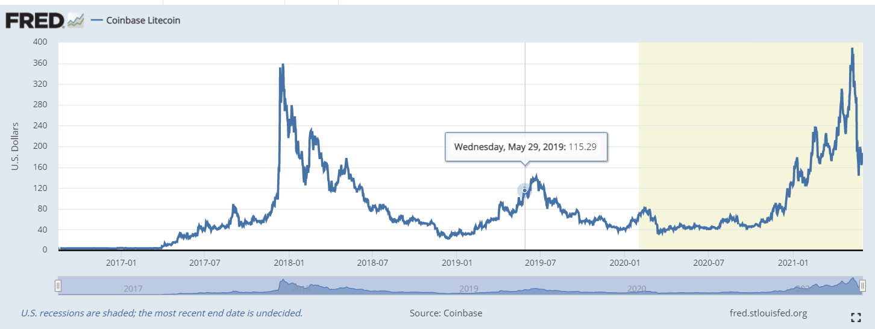

1. Ethereum

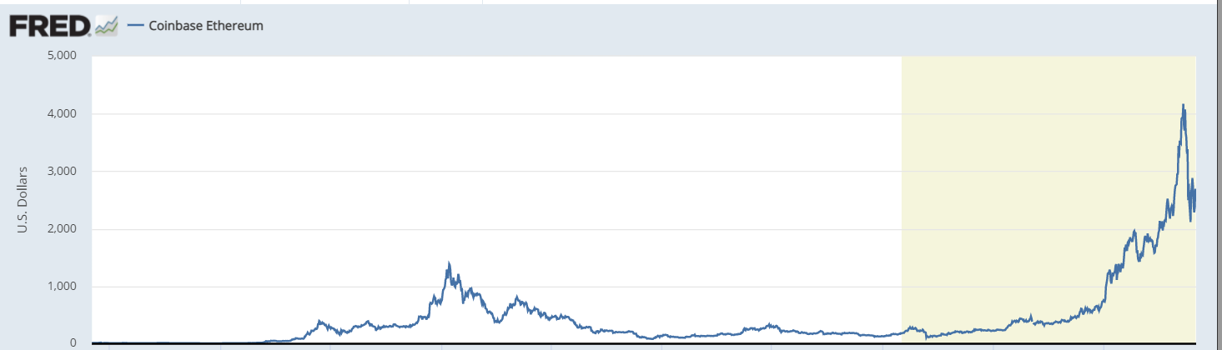

1. Bitcoin

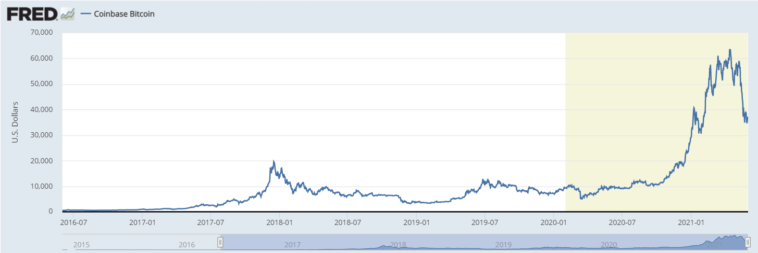

## Repo Location:

1. <https://github.com/gt-data-bootcamp/project-3>

## Inspirational Image

1. Timeline

   Description automatically generated
2. A picture containing light, night, lit, laser

   Description automatically generated
3. Chart

   Description automatically generated